Project Design Phase-II
Data Flow Diagram & User Stories
Date | 1 October 2026
Team ID | 6ab7f80ad083b0e2ee72b17e
Project Name | EduGenie: Google Gemini Powered Learning Assistant
Maximum Marks | 4 Marks
Data Flow Diagrams:
Problem (PS-3): A student wants to revise what they have studied and check their understanding, but going through long study materials again and creating practice questions takes a lot of time. EduGenie generates concise revision points and personalized practice questions.
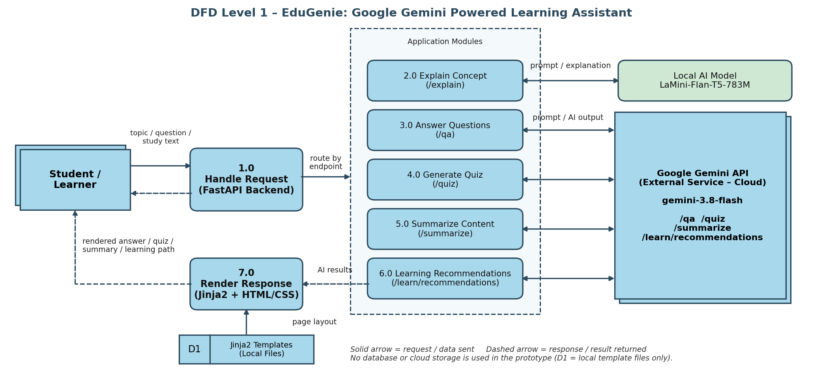
1. The student opens the EduGenie web page (HTML/CSS) and enters a topic, question or study text.
2. The request goes to the FastAPI backend (Uvicorn), which routes it to the matching feature module.
3. /explain: the local LaMini-Flan-T5-783M model generates a simplified explanation.
4. /qa, /quiz, /summarize, /learn/recommendations: the prompt is sent to the Google Gemini API (gemini-3.8-flash).
5. The AI output is returned to FastAPI, rendered through Jinja2 templates and shown to the student. No data is stored.

User Stories
User stories for the EduGenie product.
User Type | Functional Requirement (Epic) | User Story Number | User Story / Task | Acceptance criteria | Priority | Release
Student (Learner) | Concept Explanation | USN-1 | As a student, I can enter a topic or concept and get a simple explanation of it. | I receive an easy-to-understand explanation on the page. | High | Sprint-1
 |  | USN-2 | As a student, I can get explanations generated by the local model so they work without an external service. | /explain returns a result using LaMini-Flan-T5-783M. | Medium | Sprint-1
 | Question Answering | USN-3 | As a student, I can ask a question about what I am studying and get a clear answer. | I receive a relevant answer from Gemini on the same page. | High | Sprint-1
 | Summarization | USN-4 | As a student, I can paste my study material and get concise revision points. | I receive a short summary with the key points. | High | Sprint-2
 |  | USN-5 | As a student, I can save time by not re-reading long notes before exams. | Summary is much shorter than the original text and covers main ideas. | Medium | Sprint-2
 | Quiz Generation | USN-6 | As a student, I can generate practice questions from a topic or my study material. | I receive a set of practice questions without writing them myself. | High | Sprint-2
 |  | USN-7 | As a student, I can check my answers to the quiz to know if I understand the topic. | I can see correct answers and judge my understanding. | Medium | Sprint-2
 | Learning Recommendations | USN-8 | As a student, I can get suggestions on what to learn next. | I receive a learning path with next topics to study. | Medium | Sprint-3
 | Web Interface | USN-9 | As a student, I can use all features from one simple web page. | Explain, Q&A, Quiz, Summary and Recommendations are accessible from the UI. | High | Sprint-1
 |  | USN-10 | As a student, I see a clear message if the Gemini service is unavailable. | A friendly error message is shown instead of a crash. | Low | Sprint-3
Administrator / Developer | Setup & Security | USN-11 | As an administrator, I can keep the Gemini API key in an environment variable. | The API key is not exposed in code or in the browser. | High | Sprint-1
 |  | USN-12 | As an administrator, I can run the app locally on a Uvicorn server. | The app starts locally and all pages load. | Medium | Sprint-1

